**University of Karachi**

**Department of Computer Science**

Computer Graphics

Project Proposal

Platform: Unity 3D

Group Members:

Ebaad Ahmed (B12101024)

Salman Elahi (B12101109)

Kamran Tariq (B12101039)

Submitted to:

Miss Humaira Bashir

**Game:** **Cross Walk**

1. **Theme:**

This is a 3d game, it will challenges you to cross the road and the railway track without getting hit from the bus, car or train and pick up the coins to increase your score

1. 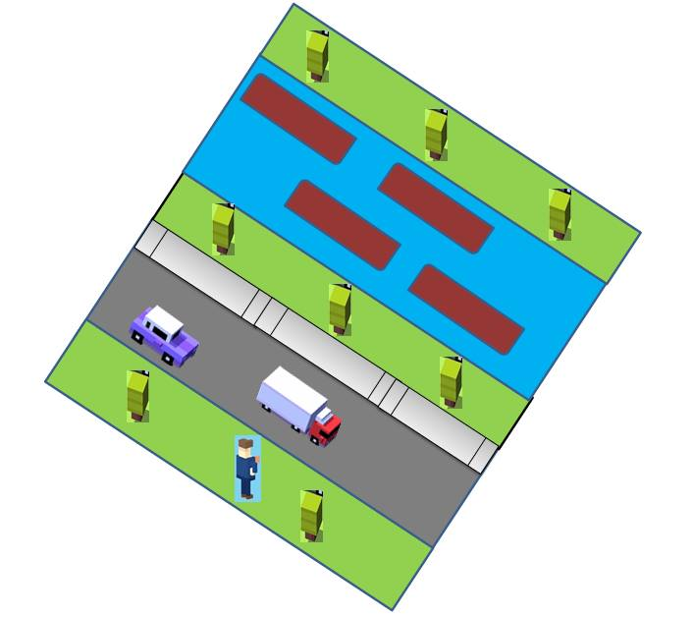**Screenshot:**
2. **Models:**

* Cars
* Trucks
* Train
* Boats
* Boy
* Coins

1. **Animations:**

* Cars
* Trucks
* Train
* Ships
* Boy

1. **Classes:**

* Boy Class
* Animated Object Class
  + Car class
  + Truck class
  + Boat class
  + Train class

1. **Collision Detection / Boundary Check**:

* Cars
* Trucks
* Trains
* Boxes
* Walls